**5 Data Recovery Windows Software**

1. MiniTool Power Data Recovery  
   1. About

MiniTool Power Data Recovery is an all in one data recovery program developed by MiniTool Solution Ltd., and it can help recover files lost due to different kinds of logical errors, like mistaken deletion, accidental formatting, and sudden power outage. After years of development, now it has been largely optimized both in scanning speed and data recovery rate, thus already winning thousands of supporters all over the world.

* 1. Features
* Damaged Partition Recovery
* CD/DVD Recovery
* Deleted File Recovery
* Digital Media Recovery
* Support Scan lost files in Windows Server
* Support Windows Dynamic Disk Volume (Mirrored Volume, Striped Volume, Spanned Volume, RAID-5 Volume)
* Free Edition

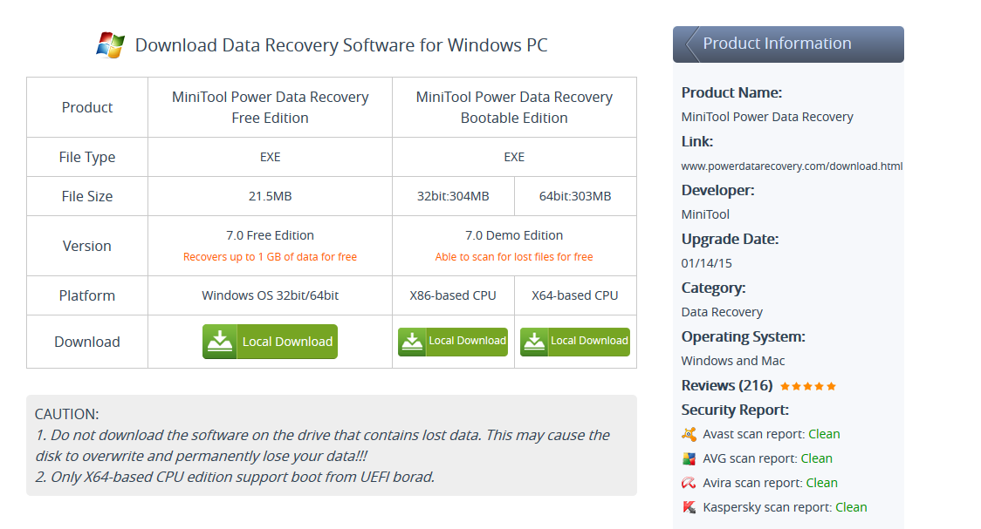

* 1. Reviews
* " MiniTool Power Data Recovery Free Edition is a free file- and data-recovery tool for Windows. It bundles several tools that together can recover lost and deleted data from hard drives, USB drives, and nearly every kind of disk or directory that can hold (and lose) data. " - By-Download.com staff - FROM CNET
* " While Power Data Recovery Personal from MiniTool is not the best file recovery tool, it still rightfully earns a place in the top ten options for this type of tool. Beyond its above-average performance in recovering formatted files, it features built-in small device and RAID recovery capabilities. " - From TopTen Reviews

1. 7- Data Recovery  
   1. About

Complete and capable data recovery software for rescuing files under almost any conditions including: accidentally deleted files; damaged or formatted hard drive; lost/deleted partition; photo or video lost from local drive, memory card, or camera; file lost from mobile phones, etc. It also has sub-products such as: SD Memory Card Recovery; Digital Photo Recovery; Disk Partition Recovery; and Android Data Recovery.

* 1. Features
* Recover data from both local drives and mobile storage devices
* Recover documents, emails, photos, videos, audio files and more
* Recover 1 GB data for free with the Free Edition  
  1. Reviews
* “I am very impressed with the software for ease of use and clarity of guidance”– Ann Lawrence, Sculthorpe, United Kingdom
* **“This is top quality software that pays for itself the first time you use it”–** Raymond Cowie, Loughborough, UK
* **“I have wasted so much time searching and searching for good recovery tools before I was told about this. “–** May Renolds, Melville, New York

1. Office Recovery (Recovery for Word)  
   1. About

Recovery for Word is designed for effective data recovery from corrupted Microsoft Word documents. Using Recovery for Word allows to avoid the loss of important information. Nowadays Microsoft Word textual processor is the most widespread tool for creation any types of documents, including corporate documents.

Recovery for Word scans, analyzes the corrupted file and exports all available data from the file. If the document is strongly damaged, some data loss is inevitable. All restored data is saved into a new rtf document. After the recovery the document becomes available for processing. Recovery for Word repairs text and formatting, tables, bulleted lists, embedded graphics (images are placed at the end of the recovered document), charts and drawings, headers and footnotes, fields, including URLs, OLE objects and so on.

The important fact is that the program only analyzes the damaged file and does not change the original data. Recovery for Word works with text files of various formats: Microsoft Word documents of different versions (.doc, .docx and .docm files) and Rich Text documents (.rtf files).

What if no data to recover detected in your damaged word file? You can order a file review by our technical team. In some cases it is possible to retrieve data only manually.

* 1. Features
* Supports all modern file versions, including 2007, 2003, 2002, 2000 and 97
* Basic support for Word for Macintosh files
* Supports RTF (rich text format)
* Recovers text and formatting
* Recovers tables
* Recovers bulleted lists
* Recovers embedded graphics (images are placed at the end of recovered document)
* Recovers charts and drawings
* Restores headers and footnotes
* Recovers fields, including URLs
* Recovers OLE objects
* For Word 2007 and 2010 the following OLE objects are restored:
  + Package
  + Bitmap Image
  + Microsoft Equation 3.0
  + Microsoft Graph Chart
  + Microsoft Power Point 97-2003 Slide
  + Microsoft Visio Drawing
  + Microsoft Works Spreadsheet
  + OpenDocument objects(of any type)
  + WordPad Document
* Restores formatting applied by styles, recovers headers and footers, fields and bookmarks
* Recovers password-protected files if the password is known (Word 2003, 2002, 2000 and 97 files only)
* Full install/uninstall support
  1. Reviews
* *“We had a major server crash that destroyed a RAID Array. We used the software to try to recover from the .EDB files that were retrieved using other partition recovery software. Recovery for Exchange Server helped us recover over 8700 contacts from our backups and while a few months old, they are critical to our organization. The software worked great, I was surprised by the software's power and accuracy.” -* Gerry O.
* *“I'm not sure what had happened to the database, but it could not be opened. Your software did a full recovery and rebuild, and all went back to normal operation. I was impressed.” -* Jim K.

1. Ease Us  
   1. About

Established in 2004, EaseUS always takes the responsibility for better serving great users to protect their data security as its destiny and never stops moving forward on the path of solving troublesome data cases over 180 countries and areas. As an worldwide renowned professional software developer, EaseUS always takes the lead in solving users data troubles with data backup, data recovery and storage management solutions.

What makes EaseUS unique is that we take the goal to make your life easy as our eternal mission so that we’ve produced multiple excellent softwares to solve data problems on PC, Mac, iOS & Android devices.

EaseUs has 4 different applications, such as: Data Recovery Wizard which is the Free Edition; Data Recovery Wizard Pro for $69.95; Data Recovery Wizard Pro with WINPR for $99.90; and Data Recovery Wizard Technician for $499

* 1. Features
* **Amount that can recover**: 2GB
* **Data loss situations (**IMPROVED): Recover deleted, formatted, inaccessible data
* **Supported devices:** Recover lost data from PCs, laptops, digital devices, hard drive(HDD, SSD, USB, etc), storage media, server, RAID etc.
* **Lost partition recovery (**IMPROVED): Recover data from deleted, hidden, lost or raw partition
* **RAW recovery:** Retrieve lost files by scanning storage device in deep level
* Export or import scanning results
  1. Reviews
* “Thank you a lot for providing such a masterpiece. once again thank you sir and your team. Excellent! Restored all my data and precious family photos! No corrupt files, easy to use and affordable! “ – Tom Gackell
* “Unbelievably easy to use and full of just the right features. If you are migrating your data or backing up your system, EaseUS Todo Backup is the software for you.” – Don Cheney

1. Data Rescue PC3  
   1. About

One of the top applications in the web is the Data Rescue PC3 application, why? Because it set itself to be the best in data recovery software for logical data recovery loss, this software develops and backed by Data Recovery Center in Livermore, California, where it gets used in a professional data recovery environment every day. It is made for more than just recovering individual files. It can also help you recover boot records, partition tables and complex RAID configurations.

Using this hard drive recovery software, the user can choose to recover individual files, so that can recover the files that only the user needed not all lost file. Of course, the user wants to recover the important files that the user can use let’s say some class project or controversial files. On the other hand, to save some time you don’t need to recover some photo and files. This data recovery software gives you a choice.

* 1. Features

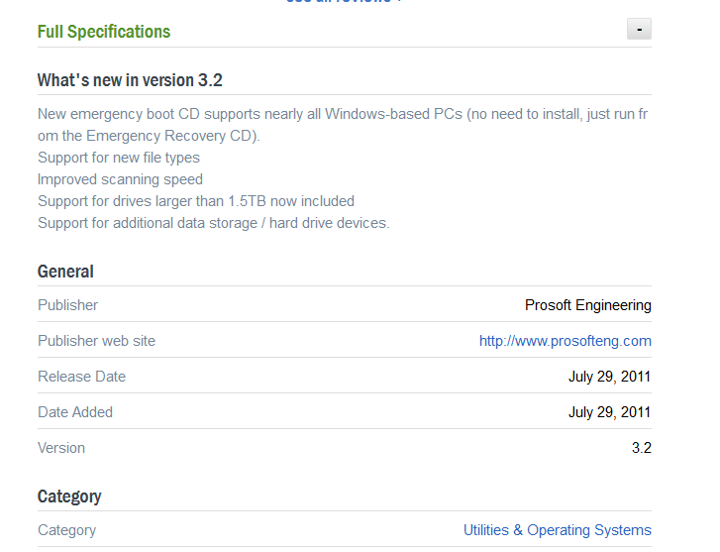

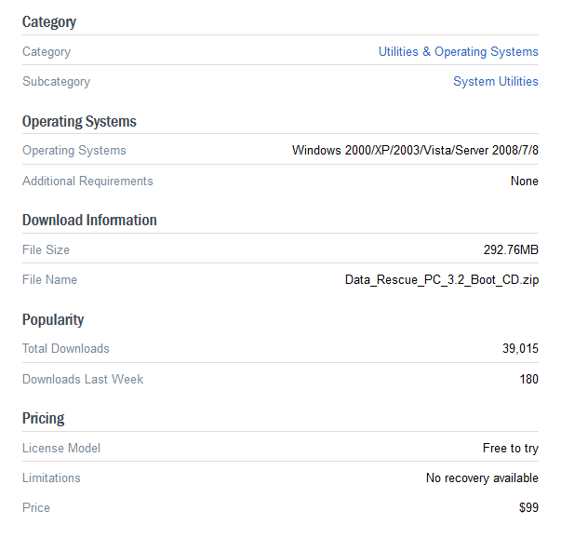

Testing:

1. Mini Tool Power Data Recover  
   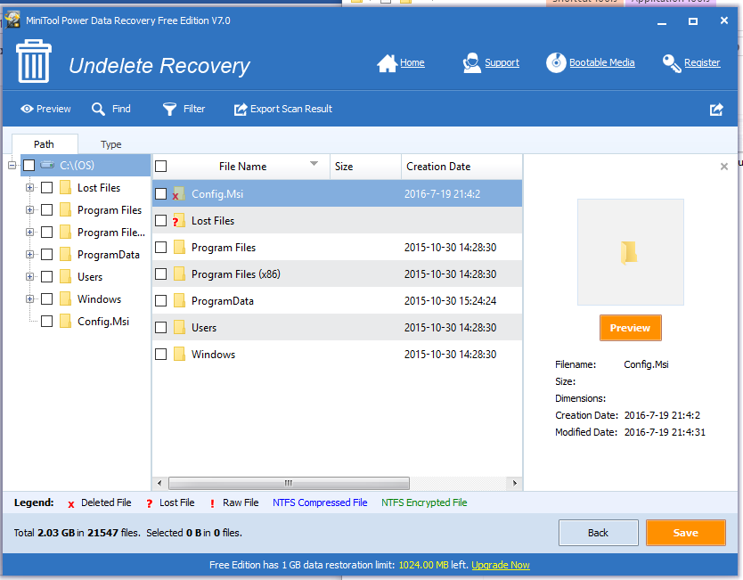
2. 7-Data Recovery

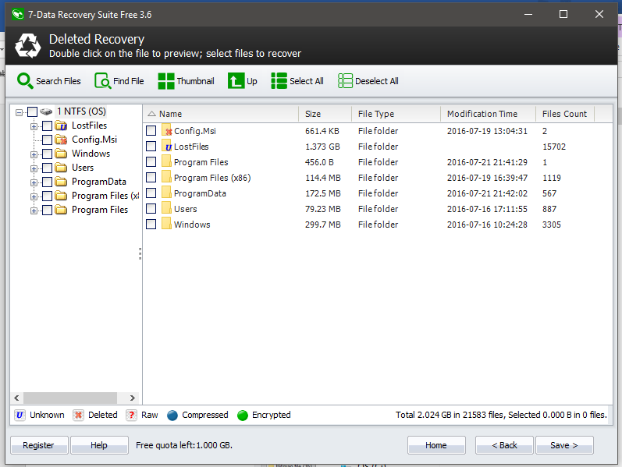

1. Office Recovery (Recover for Word)

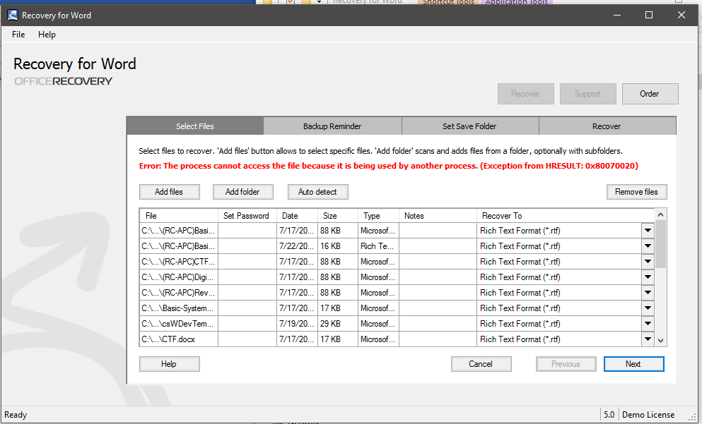

1. Ease Us

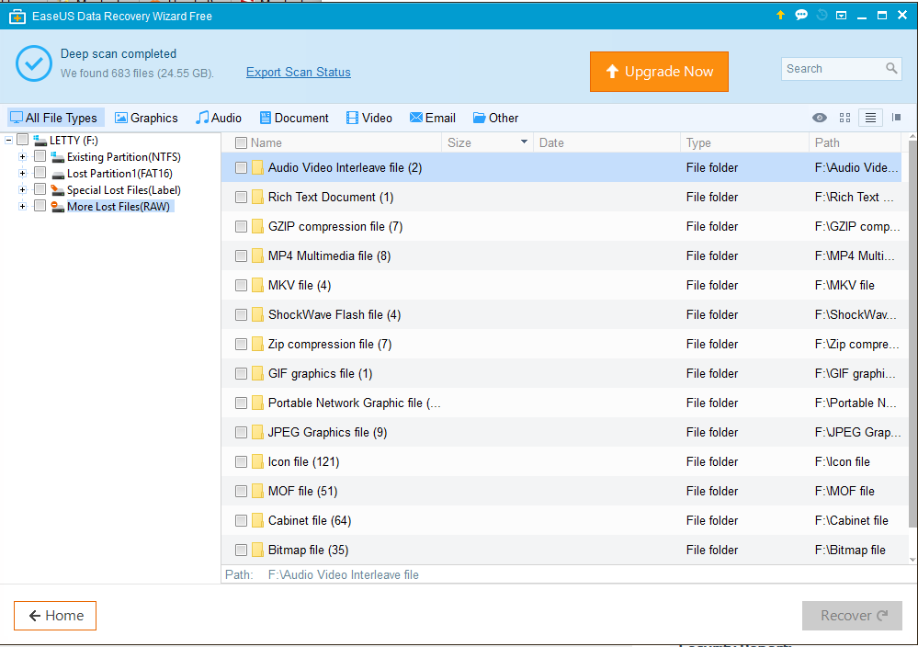

1. Data Rescue PC3

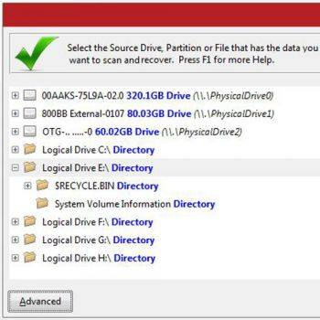

Evaluation:

|  |  |  |  |  |  |
| --- | --- | --- | --- | --- | --- |
| Software | Features | System Specification | Remarks | License Type |  |
| MiniTool Power Data Recover | * Damaged Partition Recovery * CD/DVD Recovery * Deleted File Recovery * Digital Media Recovery * Support Scan lost files in Windows Server * Support Windows Dynamic Disk Volume (Mirrored Volume, Striped Volume, Spanned Volume, RAID-5 Volume) * Free Edition |  | Based on how I used the application, it seems it’s a good application to use because it can really retrieve my lost, damage or even deleted files. I showed up there the testing of the application, it is also reliable application. | Freeware |  |
| 7- Data Recovery | * Recover data from both local drives and mobile storage devices * Recover documents, emails, photos, videos, audio files and more * Recover 1 GB data for free with the Free Edition |  | According on how I tested the application. So far, it’s easy to use and also a reliable application. It’s a friendly-user. | Freeware |  |
| Office Recovery (Recovery for Word) | * Supports all modern file versions, including 2007, 2003, 2002, 2000 and 97 * Basic support for Word for Macintosh files * Supports RTF (rich text format) * Recovers text and formatting * Recovers tables * Recovers bulleted lists * Recovers embedded graphics (images are placed at the end of recovered document) * Recovers charts and drawings * Restores headers and footnotes * Recovers fields, including URLs * Recovers OLE objects * For Word 2007 and 2010 the following OLE objects are restored:   + Package   + Bitmap Image   + Microsoft Equation 3.0   + Microsoft Graph Chart   + Microsoft Power Point 97-2003 Slide   + Microsoft Visio Drawing   + Microsoft Works Spreadsheet   + OpenDocument objects(of any type)   + WordPad Document * Restores formatting applied by styles, recovers headers and footers, fields and bookmarks * Recovers password-protected files if the password is known (Word 2003, 2002, 2000 and 97 files only) * Full install/uninstall support |  | This application gave me an idea on how we can manipulate our project because Word Document is one of our scope for our project. Anyway, this application showed to me that it can really retrieve a word documents | Freeware |  |
| Ease Us | * **Amount that can recover**: 2GB * **Data loss situations (**IMPROVED): Recover deleted, formatted, inaccessible data * **Supported devices:** Recover lost data from PCs, laptops, digital devices, hard drive(HDD, SSD, USB, etc), storage media, server, RAID etc. * **Lost partition recovery (**IMPROVED): Recover data from deleted, hidden, lost or raw partition * **RAW recovery:** Retrieve lost files by scanning storage device in deep level * Export or import scanning results |  | Based on how I used the application, of course my lost files were already recovered and also, I’m glad that is already categorize. | Freeware |  |
| Data Rescue PC3 | * Quick scans and full scans * Reports on file recoveries * Convenient plug-and-play operation * File previews so you can decide whether you want to recover a specific file * Lists of component changes and detailed information |  | This software provides a disk-imaging feature that lets you to make a byte-by-byte copy of your disk in the early stages of mechanical failure meaning this software approaches the hard drive to search the most recently if ever your file has been recently accidentally deleted or recently gone the soft ware had given you a lot of question to be able to recover the file that you looking for. | Freeware |  |

According on how I used every software above there, as I evaluate all of them, they have the same function on how to recover the previous or deleted files. Its Interface are almost the same. They can recover on any kind of storage device like Hard drive, Flash Drive, and External Hard Disk. Also, they can recover any kind of file but there this software can be specific on what file it can be recovered. The Office Recovery for Word is a recovery software that can recovers only the extended file name of the Word. Based on this software, this will help us on our project because the scope of our project are the text files. It gave us idea on how can we manipulate our software thru this. All of them are good software to use, it gave us path on our software that we are doing. These software helped us to understand how the recovery is working.